Membership Management
- Create database for DRYA Membership (fields to be determined and based on current database)
Note: [2:04:43 PM 11-Nov-2025] Covered by: CLUB, PERSON
- Remember data from previous years in registration and allow for updates
Note: [2:05:23 PM 11-Nov-2025] Data will timestamped with: Created_ts, and Updated_ts
Note: [2:05:59 PM 11-Nov-2025] All Results will include: Race_id this is mark Season, Date, Time
- Must accommodate all DRYA membership types (Section 24 ByLaw Article 1)
  - Sustaining Members
  - Provisional Members
  - Family Members
  - Junior Members
  - Collegiate Members
  - Associate Members
  - Contributing Members
Note: [2:12:53 PM 11-Nov-2025] Covered by: enum_OrgMembership
- 1/1/26 must be available to handle 2026 registrations

- Must be able to register to race choice of
  - PHRF only
  - ORC only
  - PHRF and ORC
Note: [2:17:46 PM 11-Nov-2025] To be automatic based on pulled CERTs
- Identify when a boat applies for a PHRF and/or ORC certificate
Task: [2:18:08 PM 11-Nov-2025] Need periodic task to poll for Cert Applications, or make user defined
- Identify when a boat receives a PHRF and/or ORC certificate and update the appropriate ratings in the database (hopefully automatically)
Task: [2:18:49 PM 11-Nov-2025] Periodic Task with constraints, e.g.: CERT cannot be changed during a SERIES
- Handle payment of dues
Task: [2:19:51 PM 11-Nov-2025] What? New to me but OK, STRIPE.
- Handle payment of race registration

- Handle registration of guest boats per regatta along with payment
  - Sheila Note: Have all of the clubs put a link to this part in their NOR so all guest boats are registered at one point only
Task: [2:20:38 PM 11-Nov-2025] Guest login required, to capture PERSON, BOAT, PAYMENT
- Handle payment for class changes
Task: [2:21:13 PM 11-Nov-2025] Store Item keyed to changing Classes inside a SERIES
- Handle boats that are dual owned, i.e. both owners need to register with the same boat
- Handle owners with multiple boats

Note: [2:21:45 PM 11-Nov-2025] BOATs and PERSONs are separate in the DB design, and linked, one to many, many to one, e.g.: One BOAT can be owned by ma

- Handle certificate (rating) changes
Task: [2:23:31 PM 11-Nov-2025] To be controlled by RACE, REGATTA, and SERIES, cannot affect RACEs in the PAST with ADMIN override
- Possibility of handling Junior Sailing program registration
Note: [2:24:17 PM 11-Nov-2025] Just another SERIES, with BOATs, and PERSONs

Pre-season Setup
- Setup list of regattas for the season as well as requirements for qualification
Task: [2:25:09 PM 11-Nov-2025] Configuration work after APP is UP, from the UI for ADMINs
Task: [2:25:37 PM 11-Nov-2025] It will consist of configuring RACEs, REGATTAs, and SERIESs
Task: [2:26:05 PM 11-Nov-2025] Each to include: [ ] ANNUAL EVENT option

- Setup classes and divisions for the year
Task: [2:26:55 PM 11-Nov-2025] Configuration work,
- Setup type of race for each regatta, P2P or W/L

Setup
- Pick Regatta for processing (and be able to switch back and forth between regattas)
Note: [3:09:02 PM 11-Nov-2025] Handles by Regatta > select from list view > Edit
- Ability to export or link to boat data and load into scoring app for each regatta
  - Export for parallel testing purposes
Task: [3:09:38 PM 11-Nov-2025] This will be the Entry Flow
- Define REGIONs, e.g.: Midwest United States (USE U.S. SAILING REGIONS)
- Define ORGs, e.g.: US Sailing, DRYA
- Define CLUBs, e.g.: LSSC, BYC, etc.
- Define SERIES, e.g.: 2026 Series, belongs to an ORG or CLUB
- Define REGATTAs, e.g.: BYC (Selected from CLUBs), named “Long Distance Regatta”
- Define RACEs, e.g.: Race #1 in the ‘BYC’ ‘Long Distance Regatta’

- Keep data for each regatta so no changes are applied if not needed (like rating changes that are not retroactive)
Note: [3:22:23 PM 11-Nov-2025] Covered, UUID storage of all records for a complete historical pictures of any event and all results.
- Add guest boats per regatta (currently identify by Club-Guest)
Task: [3:23:04 PM 11-Nov-2025] Will require: PERSON created as OWNER of a BOAT
Note: [3:23:37 PM 11-Nov-2025] After creating a GUEST BOAT it will be available forever like normal boats but will be distinguished by TYPE and/or STATE
Task: [3:25:54 PM 11-Nov-2025] The STATE of all BOATs will go to INACTIVE at the end of a SEASON.
- Allow updates to data per race, i.e. temporary class change, rating updates
Note: [3:26:49 PM 11-Nov-2025] HMMMM. This could be difficult.
- Check for data errors in sail number, time input etc.
Note: [3:28:03 PM 11-Nov-2025] SAIL NUMBERs will not be entered, they will be SELECTED from ‘KNOWN GOOD’ BOAT definitions, either by typing in SAIL NUMBER (search) or BOAT NAME, or scrolling thru BOATs registered for the REGATTA/RACE your are scoring.
- Display list in various sort orders, for example by boats, class, sail number, boat name, type of boat, owner, ratings
Note: [3:29:39 PM 11-Nov-2025] 10-4

- Setup race details: start time, distance, course sailed per class, time limits
Note: [3:44:25 PM 11-Nov-2025] Covered in RACE definition

- Allow entry of start data for up to 3 races (for W/L and maybe P2P (HH))
Note: [3:44:54 PM 11-Nov-2025] No limit on RACEs per REGATTA

- Setup ORC data to use various wind bands (5 band or 3 band per race and race type)

- Setup PHRF data to use HCP for W/L and DHCP for P2P

- Print RC data, check-in sheets, duplicates by boat name and by sail number
- Calculate race length based on leg length and number or legs, or modified Olympic course
- Add classes, like DBL JAM, DBL Spin, Multihull or other club-specific classes and identify their division, course and start data

Task: [6:29:52 PM 04-Dec-2025] During Person creation
- CLUB – allow ‘Other’ and entry of free form data
ADMIN – review and permanent entry
- BOAT – same thing

user =
{
key: “user_tim_mcguire”,
name:”Tim McGuire”,
address: “…”,
value: 0.010,
dark_mode: true,
club: [ “club_byc”, “club_glyc”,…],
}

club =
{
key: “club_byc”,
name: “Bayview Yacht Club”,
code: “BYC”,
address: “…”
},
{
id: “club_1234567890…”,
key: “club_glyc”,
name: “Great Lakes Yacht Club”,
code: “GLYC”,
address: “…”
},
{
id: “club_1234567890…”,
key: “club_dyc_duluth”,
name: “Duluth Yacht Club”,
code: “DYC”,
address: “…”
}

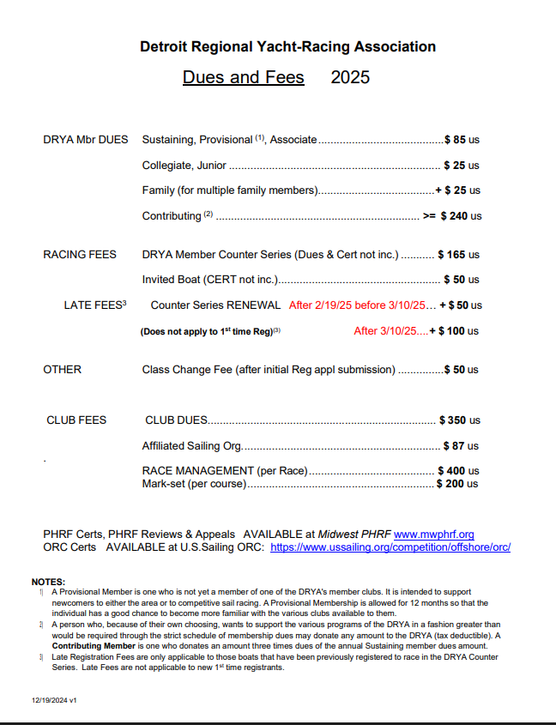

Race Data Entry
- Enter Sail Number and Finish Time (HHMMSS – no colons on entry, but colons on display)
- Allow times into the next day (currently use HH as 25, etc)
- Enter Finish Times for up to 3 races
- Determine class for each sail number (look up and display class based on sail number entered)
- If sail number is duplicated between classes, request class detail for time entry
- If sail number is duplicated within a class, request boat name for time entry
- Identify sail numbers not registered for a race
- Allow entry of character finish times, ABD, DSQ, OCS, RET, DNF, DNC, DNS, RWN, TLE (automatic and manual) with coding of finish place accordingly
- Calculate if the Time limit is exceeded and identify the finish as TLE which will get no score
- Display list of number of boats finish times recorded per class as well as total per division and regatta
- Ability to identify the boats that have started
- Display list of boats identifying which have started and those that have a finish time recorded along with a summary total by class and entire participants
- Ability to sort finish times by time finished, class, sail number, how entered to follow finish sheet order
- Allow entry of finish time for boats not registered
- Allow notes per race (multiple sections for W/L as there may be different notes for each race)
- Identify duplicate entries within a race to highlight same boat with 2 finish times
- Identify finish times entered before start times for the specific class (error check)
- Allow selection of ORC wind range (3 or 5 band based on type of race) for each race to be applied to all ORC classes
- Identify boats not recorded for 1st, 2nd and 3rd races within one regatta to ensure we have data for all 3 races
- Allow updates to finish information after scoring completed, may occur over and over for protest results, certificate corrections (record is 12 times)

Scoring
- Include DSQs in each result, per SIs
- Calculate score for each DSQ (not sure but think it is 2+ the boats started in the class)
  - Sheila question: I know if a boat does penalty turns, he exonerates himself for the “fault”, but if it goes to a protest hearing and he loses and just accepts a penalty and not a DSQ, can he throw that race out?
- Calculate finish position for OCS, RET, DNF, DNC, DNS to be total number of boats started in the class + 1
- Calculate finish position for RWN to be the total number of boats registered in the class + 1 (withdrew from race and did not notify the race committee)
- No score is used for TLE or ABD
- Handle penalties as a results of a protest, i.e. add 5 minutes
- Score boats for both PHRF and ORC (only score if a rating has been applied for or received (applied vs. received to be in line with current year NOR/SI)
- Calculate results for Race Day (with guest boats) and for Seasonal (without guest boats)
- Allow rescoring over and over
- Handle ties
  - The first tie breaker is: most 1st, most 2nd, most 3rd, etc.
  - The second tie breaker is: corrected time / distance for the regatta’s races
  - The third tie breaker is: best position in the last race
  - If there remains a tie in a race, the POSITIONS of the boats tied are added together then divided by the number of boats tied to determine the place (not sure how this works)
- Score using Time on Time methodology
- Calculate Corrected Time for all boats with a PHRF rating using the TCF based on their PHRF rating (formula: 650/(<rating>+550)
- Calculate Corrected Time for all boats with an ORC rating using the band selected for the race and the appropriate TCF for the ORC rating
- Calculate position within class for each registered boat
- Calculate position within Division for each registered boat. Note that since boats within a division may sail different course lengths, corrected times for division places will be calculated on an average per mile basis using the same ToT calculations (per scoring document)
- If a boat within a Class has not finished before the Time Limit for that Class, all boats will be scored a TLE for that class
- If a boat within a Division does finish within the Time Limit, all boats within that Division will be scored TLE for Division results. Note, this means a boat may not get a class score but will get a divisional score.
- Score time to 10 positions after the decimal for seconds (only print 2 positions after decimal)

Results
- Save an overall score (without guest boats) for the race day (overall for W/L and results for P2P) to be used in seasonal scoring. It may be updated at a future point due to rating changes or protest results possible over and over again
- Print results
  - For W/L
    - Print overall results for PHRF and ORC by Class with place, total score, sail #, boat name, owner, race 1 corrected time, race 1 score (place), race 2 corrected time, race 2 score, race 3 corrected time and race 3 score
    - Print race 1 results for PHRF and ORC by Class with place, sail #, boat name, owner, club, rating/TCF (PHRF) / TCF/wind band (ORC), type of boat, finish time, elapsed time, corrected time to the hundredths of seconds, delta from 1st place to the hundredths of seconds
    - Repeat above for race 2 and race 3 as necessary
  - For P2P
    - Print results as race 1 for P2P only – no overall
  - For each class on all results print start time, distance, 1st finish time and TLE time
  - For each race and overall print a notes section
  - Print DRYA and Organizing Authority burgees at the top of the first page of results
  - Print page number of # and date and time on the printed results
  - Allow pagination to ensure classes are not split across pages
  - Print Overall results, plus Race 1, Race 2 and Race 3
  - Print division results
  - Remove as much white space as possible from results, i.e. dynamically format results based on number of boats that raced (do not show boats that did not compete)

Seasonal
- Calculate required number of races for each seasonal series, W/L, P2P and Overall
- For Seasonal Results, use High Point scoring (points based on number of boats beat)
- Allow entry of positions for races not scored by DRYA, i.e. BYC HH Sailing World
- Take the saved data for each regatta for input/auto”upload” to seasonal results
- Drop all but the required number of races keeping just the best scores and DSQs
- Handle ties
  - The first tie breaker is: most 1st, most 2nd, most 3rd, etc.
  - The second tie breaker is: corrected time / distance for the regatta’s races
  - The third tie breaker is: best position in the last race
  - If there remains a tie in a race, the POSITIONS of the boats tied are added together then divided by the number of boats tied to determine the place. (not sure how this works)
- Print Seasonal results data (see example)
- Season Overall, W/L and P2P are needed
- Divisional Results are needed for ORC, PHRF and One-Design
- Calculate winners of special trophies based on their rules (see scoring document for list and deeds for details)

Additional Reports
- Scratch sheet for each race including any rating updates upon request
- Guest Boat list that can also be sent to hosting club
- Data analytics
  - Reports used for Hot Stove and Race Chairman meeting
  - Ad hoc
- Report of payments and registrations for reconciliation to bank deposits (for Barb)

Web Hooks

